LABORATORY OBSERVATION
Course: Full Stack Web Development
Course Code: 23CM4121
Experiment No.: 5
Student Name: Dwarapudi suswetha
Roll No.: A24126552079
Date: 20-09-2026

1. TITLE
Develop a File Handling Application Using Node.js File System Module

2. AIM
To develop a Node.js application that creates a file, writes content into the file, reads the file contents, appends additional content, and finally displays the updated file contents using the Node.js File System module.

3. OBJECTIVE
The objectives of this experiment are:
- To understand the basics of Node.js file handling.
- To use the built-in fs module in Node.js.
- To accept user input using the readline module.
- To create and write content into a file.
- To read data from a file.
- To append additional content to an existing file.
- To handle file operation errors using callback functions. ● To display the final contents of the modified file.

4. THEORY
Node.js provides several built-in modules that can be used to perform different operations without installing external packages.
The File System (fs) module is a built-in Node.js module used to work with files and directories. It provides functions for creating, reading, writing and modifying files.
The Readline module is used to read input from the user through the command-line interface. In this application, readline.createInterface() connects the standard input and output streams to allow interactive user input.
The application uses the following important functions:
- fs.writeFile() – creates a new file or overwrites an existing file with the specified content.
- fs.readFile() – reads the contents of a file.
- fs.appendFile() – adds additional content to an existing file.
- readline.createInterface() – creates an interface for reading user input.
- rl.question() – asks the user a question and receives the input through a callback function. ● rl.close() – closes the readline interface after completing the operations.
The application performs file operations in the following sequence:
User Input → Create/Write File → Read File → Append Content → Read Final File → Display Output
Callback functions are used to execute the next operation after the previous file operation is completed. Error handling is performed using the err parameter provided by the callback.

5. ALGORITHM / PROCEDURE
- Create a new Node.js project.
- Create a JavaScript file for the file handling application.
- Import the built-in fs module using require().
- Import the readline module using require().
- Create a readline interface using readline.createInterface().
- Connect process.stdin as the input stream.
- Connect process.stdout as the output stream.
- Ask the user to enter the file name.
- Ask the user to enter the initial file content.
- Use fs.writeFile() to create the file and write the entered content.
- Check whether an error occurred during the write operation.
- Display a success message if the file is created successfully.
- Use fs.readFile() to read the contents of the created file.
- Display the contents of the file.
- Ask the user to enter additional content.
- Use fs.appendFile() to add the additional content to the file.
- Display a success message after appending the content.
- Use fs.readFile() again to read the final contents of the file.
- Display the final file contents.
- Close the readline interface using rl.close().
- Test the application using different file names and content.
- Verify the expected and actual results.

6. PROGRAM
Code.js
const fs = require("fs");

const readline = require("readline");

const rl = readline.createInterface({ input: process.stdin, output: process.stdout
});

rl.question("Enter the file name: ", function (fileName) {

rl.question("Enter the content: ", function (content) {

// Create and write to the file

fs.writeFile(fileName, content, function (err) {
if (err) {

console.log("Error creating file:", err); rl.close(); return;

}

console.log("\nFile created successfully.");

// Read the file

fs.readFile(fileName, "utf8", function (err, data) {
if (err) {

console.log("Error reading file:", err); rl.close(); return;

}

console.log("\nFile contents:"); console.log(data);

// Append additional content
rl.question(
"\nEnter additional content: ", function (extraContent) {
fs.appendFile( fileName,
"\n" + extraContent, function (err) {
if (err) {
console.log(
"Error appending file:", err
);
rl.close(); return;
}

console.log(
"\nContent appended successfully."
);

// Read final contents
fs.readFile( fileName, "utf8", function (err, finalData) {
if (err) {
console.log(
"Error reading final file:", err
);
rl.close(); return;
}
console.log(
"\nFinal file contents:"
);
console.log(finalData);
rl.close();
}
);
}
);
}
);
});
});
});
});

7. CODE EXPLANATION
Code / Function | Explanation
require("fs") | Imports the built-in Node.js File System module.
require("readline"  ) | Imports the Node.js Readline module.
readline.createInt erface() | Creates an interface for accepting command-line input.
process.stdin | Represents the standard input stream from the user.
process.stdout | Represents the standard output stream.
rl.question() | Displays a question and accepts user input.
fs.writeFile() | Creates a file and writes the specified content into it.
fs.readFile() | Reads the contents of the specified file.
"utf8" | Specifies that the file should be read as UTF-8 text.
fs.appendFile() | Adds additional content to the existing file.
err | Contains error information if a file operation fails.
data | Contains the contents read from the file.
finalData | Contains the final contents after additional data is appended.
console.log() | Displays messages and file contents on the terminal.
rl.close() | Closes the readline interface.
return | Stops further execution when an error occurs.

8. TEST CASES AND EXECUTION DATA
Test  Case | File  Name | Initial  Content | Additional  Content | Expected Result
TC-01 | notes.txt | Hello  Node.js | File Handling | File created and content appended successfully
TC-02 | student.txt | Student  Record | Full Stack  Development | File should contain both contents
TC-03 | data.txt | First Line | Second Line | Second content should be appended

TC-01 output:

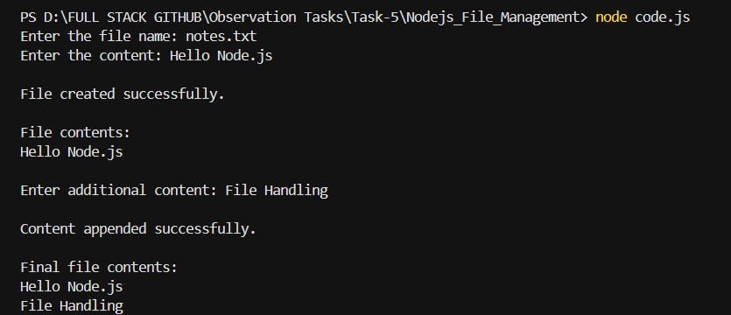
TC-02 Output:
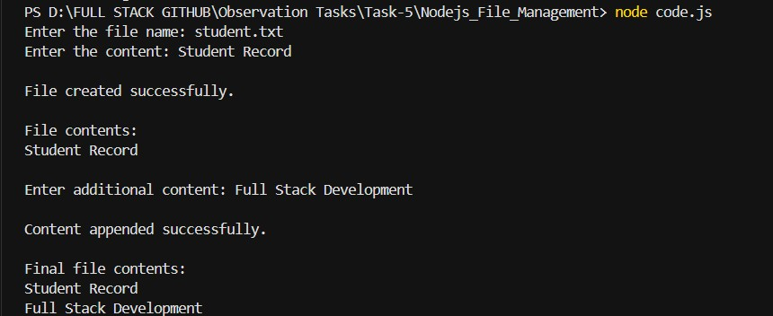

TC_03 Output:

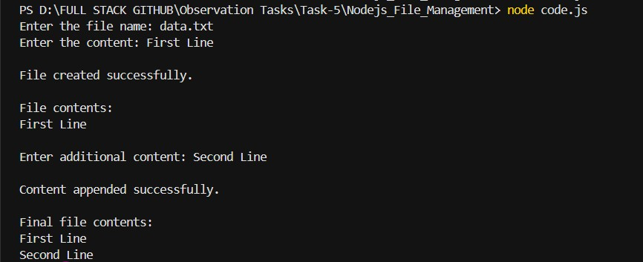

9. OUTPUT:

10. RESULT
Thus, a File Handling Application was successfully developed using Node.js, the File System (fs) module, and the Readline module. The application successfully created and wrote data to a file, read the file contents, appended additional content, and displayed the final updated contents. Error handling was also implemented for file operations.

